7th of April 2020

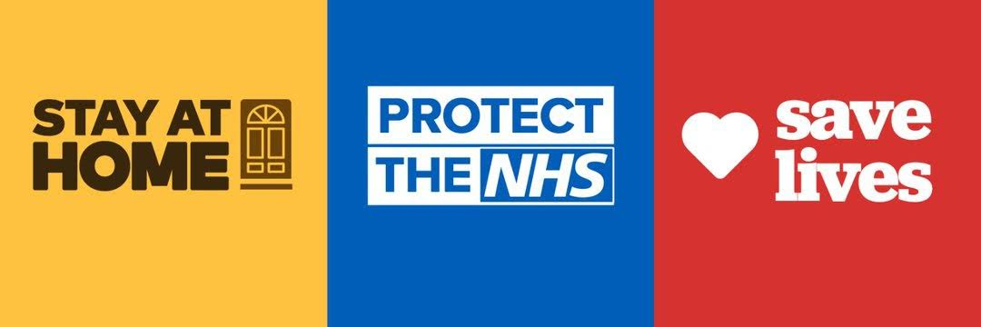

A few reminders of how you can take care of yourself and others, in accordance with government guidelines on COVID-19. Full details can be found at https://www.gov.uk/coronavirus

- Stay at home – only leave for very limited reasons.
- One form of exercise a day – please do not ask people to travel to you, if in a communal exercise group keep 2m apart.
- Wash your hands more often – especially when leaving and returning to your home.
- Social distancing – stay 2 meters away from all non-family members, like our contractors, or passing others on the stairs.
- Playing in the grounds /park– please clean/ remove any chalk drawings/ rubbish at the end of each day.
- Communal areas – keep clear of all personal items, including shoes at all times.

- General recycling- We will have more waste than normal please help us to manage the increase by:

- Flattening all boxes - as this one single action helps create more space.
- Bin stores - If the bin you were going to use is full, please use another and advise treehouse@brenleypark.co.uk

- Volunteering or need any assistance – Contact treehouse@brenleypark.co.uk if you feel we can help in any small way.

Many Thanks

Management Team, Brenley Park Management Limited
On behalf of Directors, Brenley Park Management Limited

