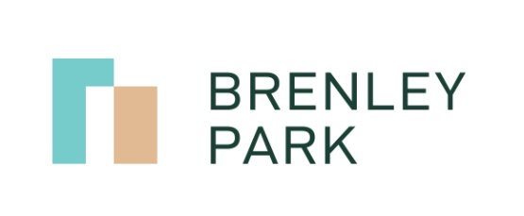

18th March 2020

Coronavirus (COVID-19)

General Information.

The safety and well-being of all our leaseholders, residents, contractors and visitors to the Brenely Park Estate continues to be a priority. We are continually monitoring the coronavirus outbreak in the UK and will continue to be guided by the government’s advice through the link below.
https://www.gov.uk/government/topical-events/coronavirus-covid-19-uk-government-response
Cleaning Information.
During these unprecedented conditions we are working closely with our cleaning contractor to ensure the safety of all. Government advice is to wash hands regularly and have minimal contact with others.

To help can you please remember to wash your hands regularly- for us this could mean when entering and exiting blocks, as this will help reduce any bacteria spreading through our communal arears.

Our cleaning operative will continue to be on site as normal but will have minimal contact with residents.

Help and Information.

If you have any concerns or you need any assistance please contact treehouse@brenleypark.co.uk

Many Thanks,

Management Team, Brenley Park Management Limited
On behalf of Directors, Brenley Park Management Limited

