**Minerva House Bin**

**Household Waste Only :**

* Please place all your bags in the bin.
* Always use bags.
* If the bin is full please find another bin which is empty.
* **Make sure the lid is closed.**
* **Do not leave waste on the floor.**
* **DO NOT LEAVE OUT FOR RATS**

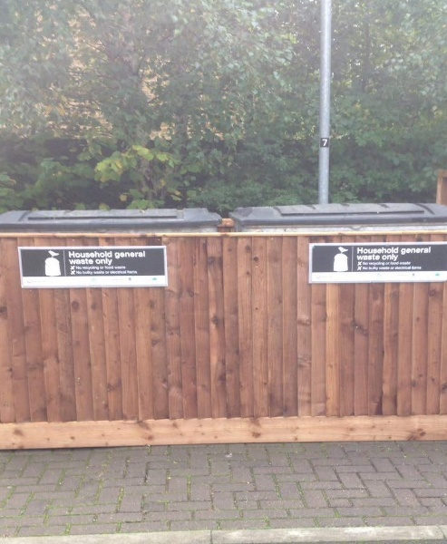

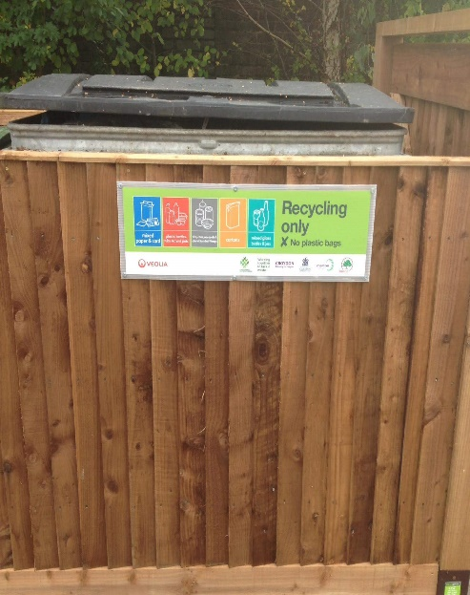

**Recycling Only:**

* Please place all your clean recycling in this bin.
* All boxes and cardboard must be flattened.
* **Make sure the lid is closed.**
* **No Bags**
* **No Food**

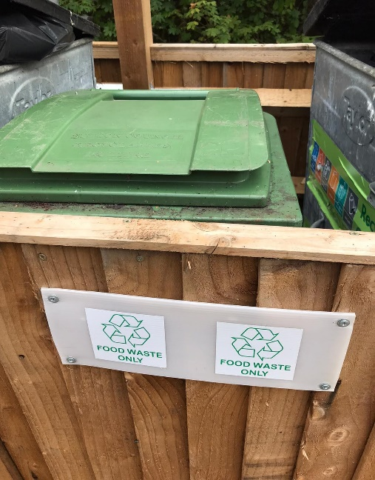

Contact [treehouse@brenleypark.co.uk](mailto:treehouse@brenleypark.co.uk) for any further help and advice.

**Food Waste Only:**

* Please place all your food recycling in here.
* Make sure the lid is closed.
* No Bags
* No Liquids