Vesta & Janus House Bin Store.
To Open: Enter code then turn the lock to the right. To Close & Lock: When leaving pull door closed and turn the knob to the left.
Where to place your waste.
Household Waste Only :
- Please place all your bags in the bin.
- If the bin is full please find another bin which is empty.
- Make sure the lid is closed.
- Make sure the door is closed and locked when you leave.
- Do not leave waste on the floor.
- DO NOT LEAVE FOR RATS

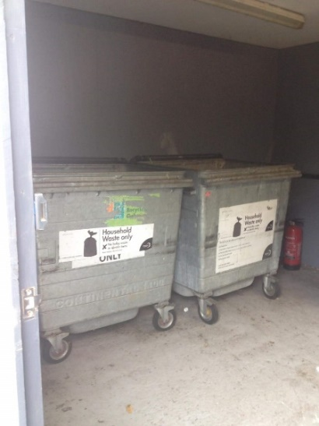
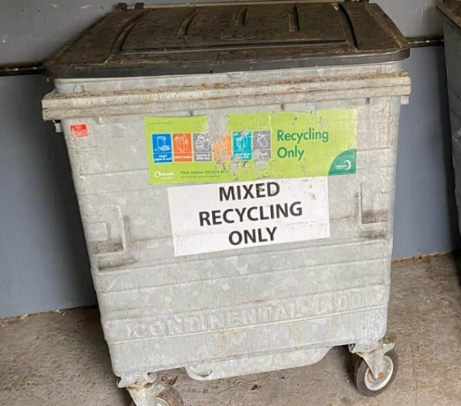
Recycling Only:
- Please place all your clean recycling in this bin.
- All boxes and cardboard must be flattened.
- Make sure the lid is closed.
- Make sure the door is closed and locked when you leave.
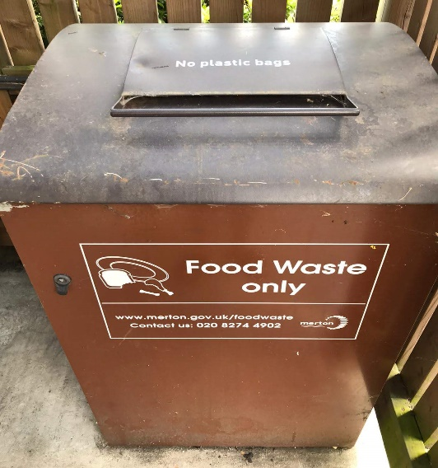
Contact treehouse@brenleypark.co.uk for any further help and advice.

Food Waste Only:
- Please place all your food recycling in here.
- Make sure the lid is closed.
- Make sure the door is closed and locked when you leave.
- No Liquids, No Packaging, No Plastic bags.

