Our A.O.V Windows.

What are our AOV windows?
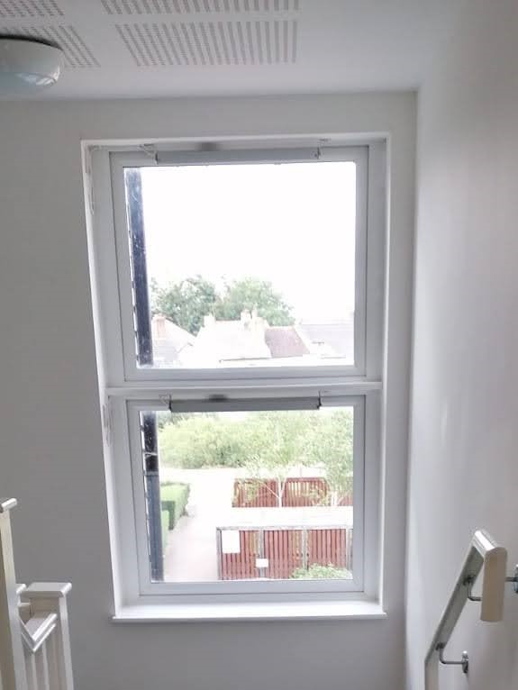

These are special windows, called Automatic Opening Vent windows.
Located on the top floor of the communal hallway. They look like this and they should be closed at all times.

Why should they be closed at all times?
They work alongside the smoke and fire alarm. When the smoke alarm is triggered, they automatically open, which allows the smoke to naturally escape outside of the building.
Why can I not open them, especially when it’s so hot?
If the windows are left open, they will not work properly in an emergency and this will compromise the safety of all within the block.

Please do not open these windows
What should I do if I see an A.O.V window open?
Please report this immediately to treehouse@brenleypark.co.uk
Many Thanks,

Management Team, Brenley Park Management Limited
On behalf of Directors, Brenley Park Management Limited

